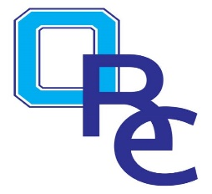

Title | Basketball Grades 3-4
Subject | Practice Plan Six
5 min.  10 min.  10 min.  10 min. | Low, Middle, High Dribble Drill  Cone Dribble Drill / Partner Passing Drill  Pass & Cut / Reverse Pivot Drill  Around the World / Make for a Cone Game
5 min.  15 min.  5 min.  Activities and procedures  Conclusions | Reverse the ball Drill  1 on 1 numbers game / 2 on 2 numbers game  Stretch and cool down (Question & answer time on today’s practice.)  See video library on www.oregonrec.recdesk.com for coaching tips,  skill building games & drills  Let the team know when the next practice will be scheduled and  end in a team huddle.

